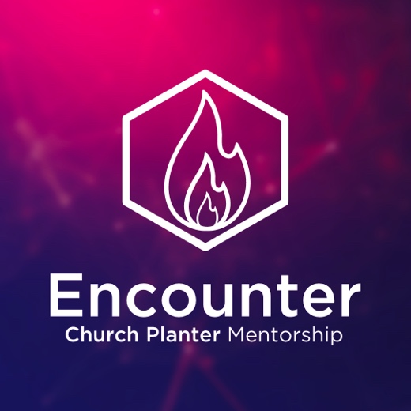

Is God calling you to plant a church?
Church planting is the best method to fulfill the Great Commission. Join a community of church planters who are starting churches in creative spaces and places throughout the world.

ATTEND ENCOUNTER WEEKEND
Encounter is a weekend designed to teach you a simple, biblical method of starting churches in creative spaces and places right away.


For more information or to RSVP, visit: www.churchdevelopment.network/events



Is God calling you to plant a church?
Church planting is the best method to fulfill the Great Commission. Join a community of church planters who are starting churches in creative spaces and places throughout the world.

ATTEND ENCOUNTER WEEKEND
Encounter is a weekend designed to teach you a simple, biblical method of starting churches in creative spaces and places right away.

For more information or to RSVP, visit: www.churchdevelopment.network/events

